Why Did “Sensor Fusion” Lose to Radar Alone?
A plain-language, data-backed explainer — every number traced back to its source file

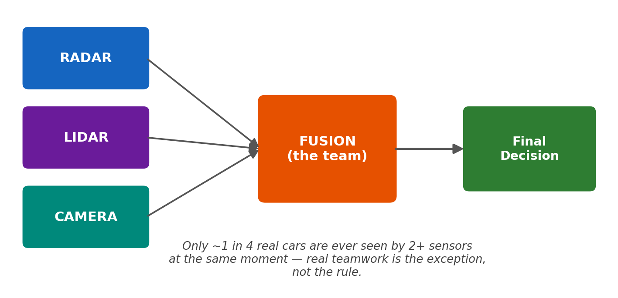

The short version
Imagine three friends standing by the road, each trying to spot cars and guess how fast they're coming: Radar (throws radio waves, works in rain/fog, good at speed), Lidar (sweeps a laser, very precise on position), and Camera (just looks — sees far and sees detail, but can't judge distance alone).
You'd expect that if all three friends work together as a team (“fusion”), the team should beat any one friend working alone. That is NOT what happened. In this project, Radar working alone was more accurate than the whole team combined.
The one-sentence answer: the “team” mostly isn't really a team. Most of the time, only one friend ever sees a given car — so “the team's answer” is usually just one friend's answer, relabeled. And the cars only one friend can see tend to be the hardest ones.

The headline numbers
On the full test — 3,376 real driving moments (“trainval”) — here's how each one scored. Lower = better (it's the average mistake, in seconds, on “when will this object reach me?”).
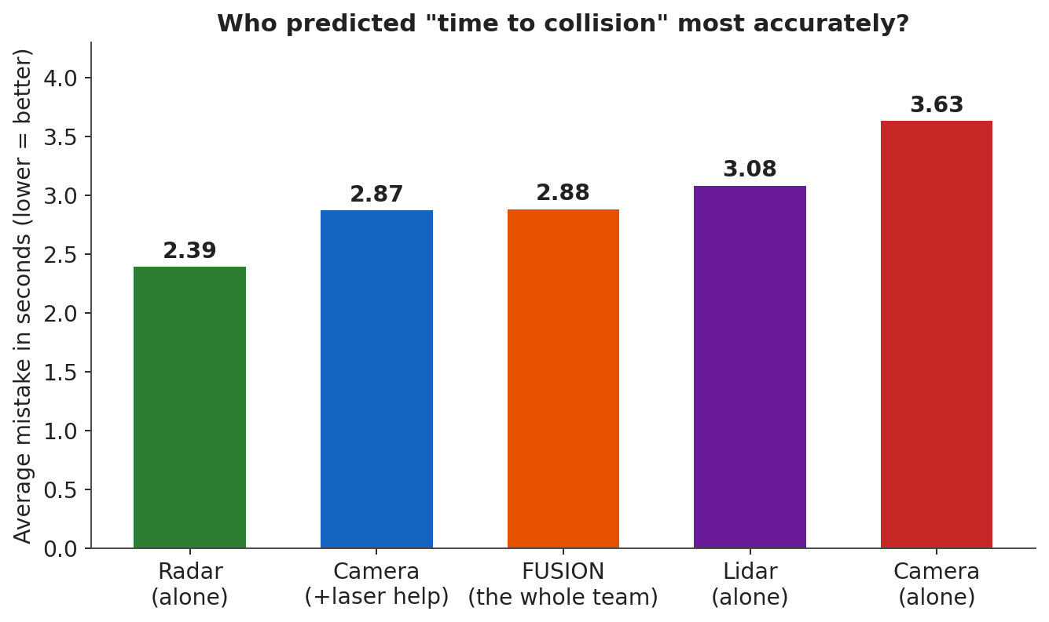
Who | Average mistake (MAE)
Radar (best alone) | 2.39
Camera (+ laser help) | 2.87
FUSION (the whole team) | 2.88
Lidar | 3.08
Camera (alone) | 3.63

Source: output/step_6/evaluation_metrics.csv (v1 notebook pipeline, trainval dataset)

Evidence 1 — Most of “the team's answer” is really just one friend talking
Imagine the “team” reports 100 car-sightings. You'd hope most are cases where 2 or 3 friends agreed. Instead, only about 1 in 4 are a real team effort — the other 3 in 4 are just one friend's guess, stamped with the team's name.
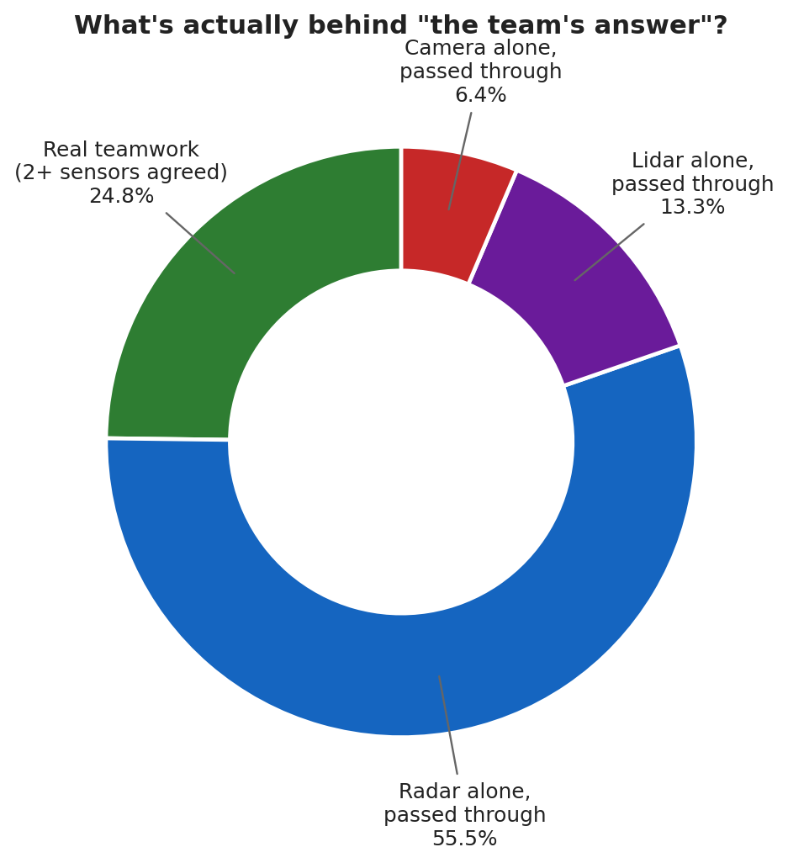
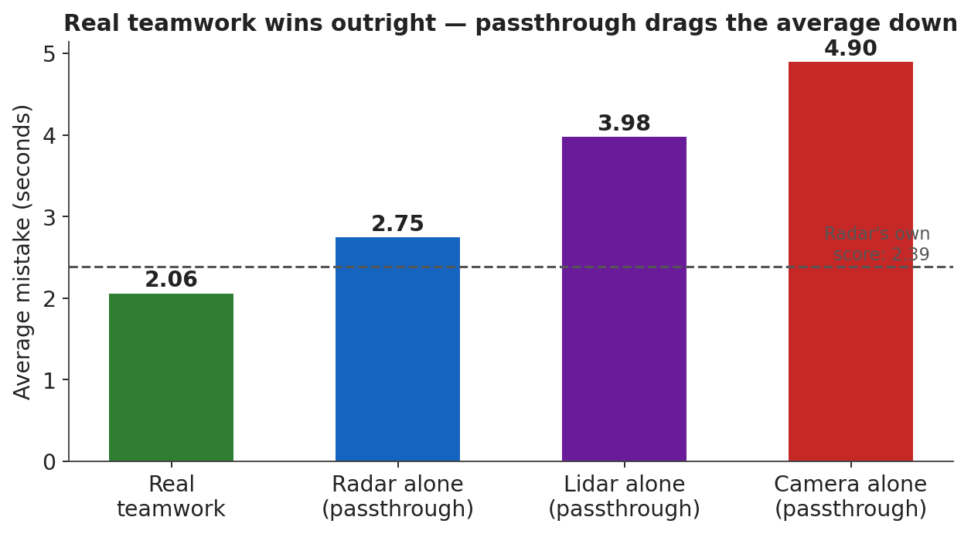
What happened | How often | Accuracy
Real teamwork (2+ friends agreed) | 24.8% | 2.06 (best of anyone!)
Just Radar alone, passed through | 55.5% | 2.75
Just Lidar alone, passed through | 13.3% | 3.98
Just Camera alone, passed through | 6.4% | 4.90

When the friends actually work together, they do the best job of anyone — teamwork itself is not the problem. The problem is teamwork almost never happens.
Source: Verified against output/step_6/evaluation_metrics.csv and output/step_4/fused_tracks_all.csv (the math 0.248×2.06 + 0.752×3.15 = 2.88 exactly reproduces the real team score). v1 pipeline, trainval dataset.

Evidence 2 — The friends usually can't even see the same car at once
For teamwork to happen, at least 2 friends need to be looking at the SAME car at the SAME moment. How often does that actually happen?
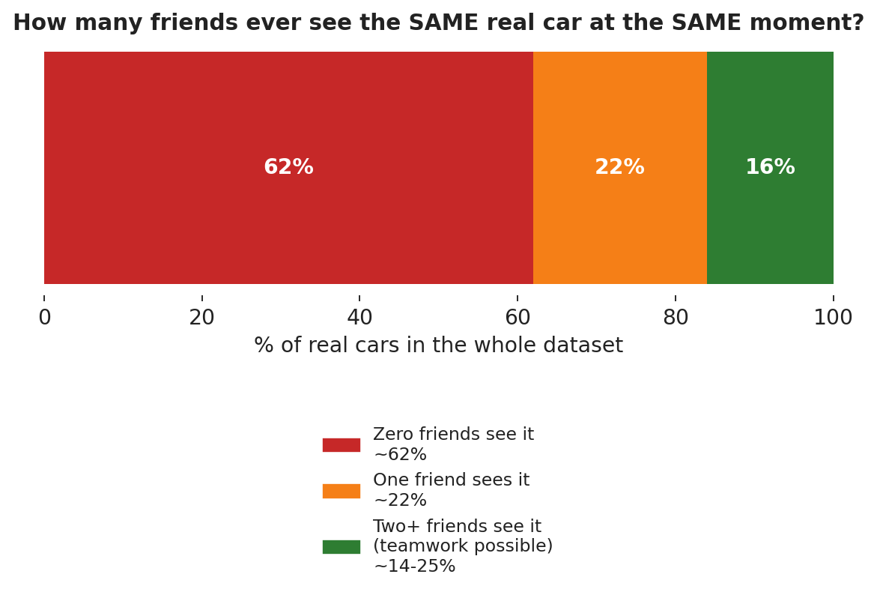
How many friends see the same car | How often
Zero friends see it at all | ~61-63%
Exactly one friend sees it | ~21-23%
Two or more friends (teamwork possible) | ~14-25%

This is a hard ceiling. Even a perfect team can only do real teamwork on 14-25% of real cars — the rest is automatically “pass the one friend's answer through.”
Source: CLAUDE.md, “second audit round” and “Radar declutter filter relaxed” sections. v1 pipeline, mini dataset.

Evidence 3 — Far-away cars are usually camera-only, so teamwork becomes impossible
A natural worry: “what if a car 150 meters away is only visible to the camera, and that unfairly drags down the team's score?” We checked this directly.
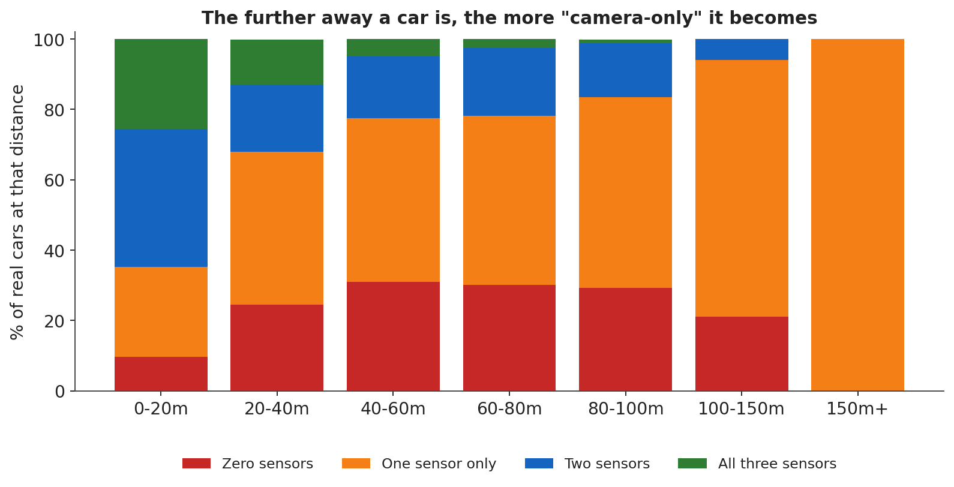
Distance | No friend sees it | Only ONE friend sees it
0-20m (close) | 9.7% | 25.5%
40-60m | 30.9% | 46.7%
100-150m | 21.0% | 73.0%
150m or further | 0.0% | 100.0%

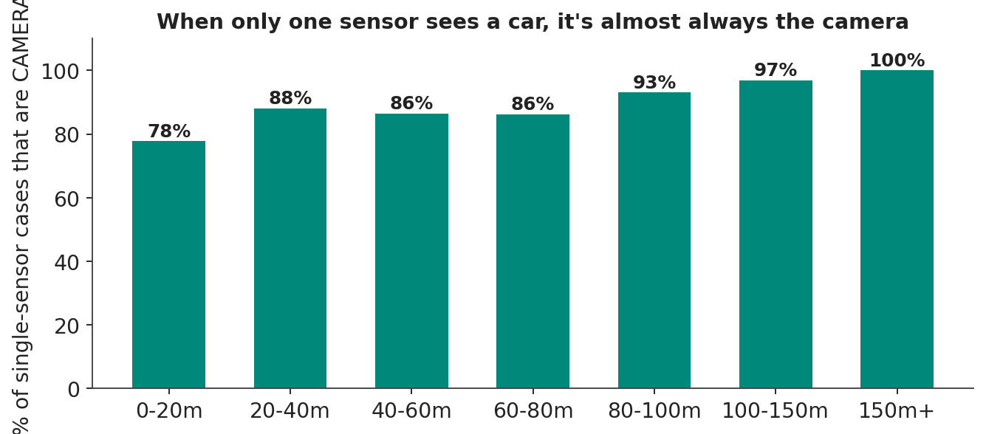
Beyond 150 meters, every single car is a camera-only case. Teamwork isn't rare there — it's impossible, every time.
Source: v2_miss_funnel.csv, 107,206 real car-sightings. v2 (rebuilt) pipeline, trainval dataset. Full writeup: docs/hypotheses-2026-10-10.md, “ROI/range follow-up” section.

Evidence 4 — Do “Radar-can't-see-it” cars actually hurt the team's score?
Evidence 3 shows far cars are camera-only. This asks the sharper question: does that actually hurt the team's final score? We split every team-reported car into two piles: cars Radar ALSO saw, and cars Radar NEVER saw.
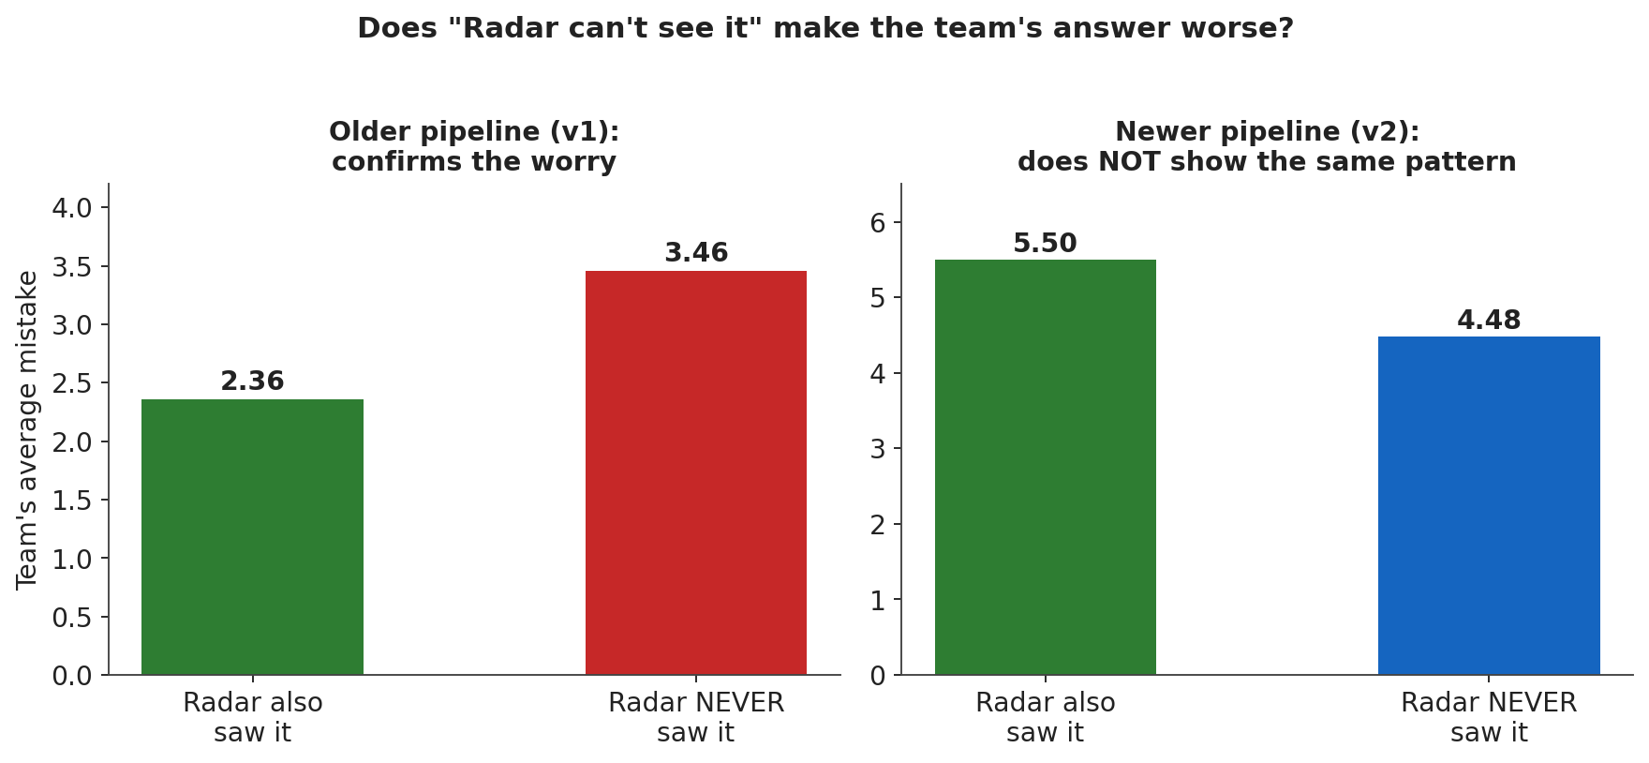
Pipeline | Radar also saw it | Radar NEVER saw it | % of cars Radar can't see
Older (v1) | 2.36 | 3.46 (worse) | 26.8%
Newer (v2) | 5.50 | 4.48 (better, not worse) | 25.2%

In the older pipeline, this confirms the worry directly — cars Radar can't see really are the hard ones. We're reporting the newer pipeline's result honestly even though it doesn't match: there, the “Radar-invisible” cars are NOT the harder ones. The mechanism is real, but it isn't the whole story for every version of the system.
Source: output/eval_l3/h6_v1_keys.csv and h6_v2_keys.csv. Both v1 and v2 pipelines, trainval dataset.

Evidence 5 — We found and fixed two real teamwork bugs — they helped, but not enough
Two real mistakes were found in how the team's answers get combined. Bug A: the system kept “forgetting who's who,” causing one real car to be counted as up to 10 different cars. Bug B: when two friends' opinions drifted apart for one instant, the system sometimes invented a brand-new fake car.
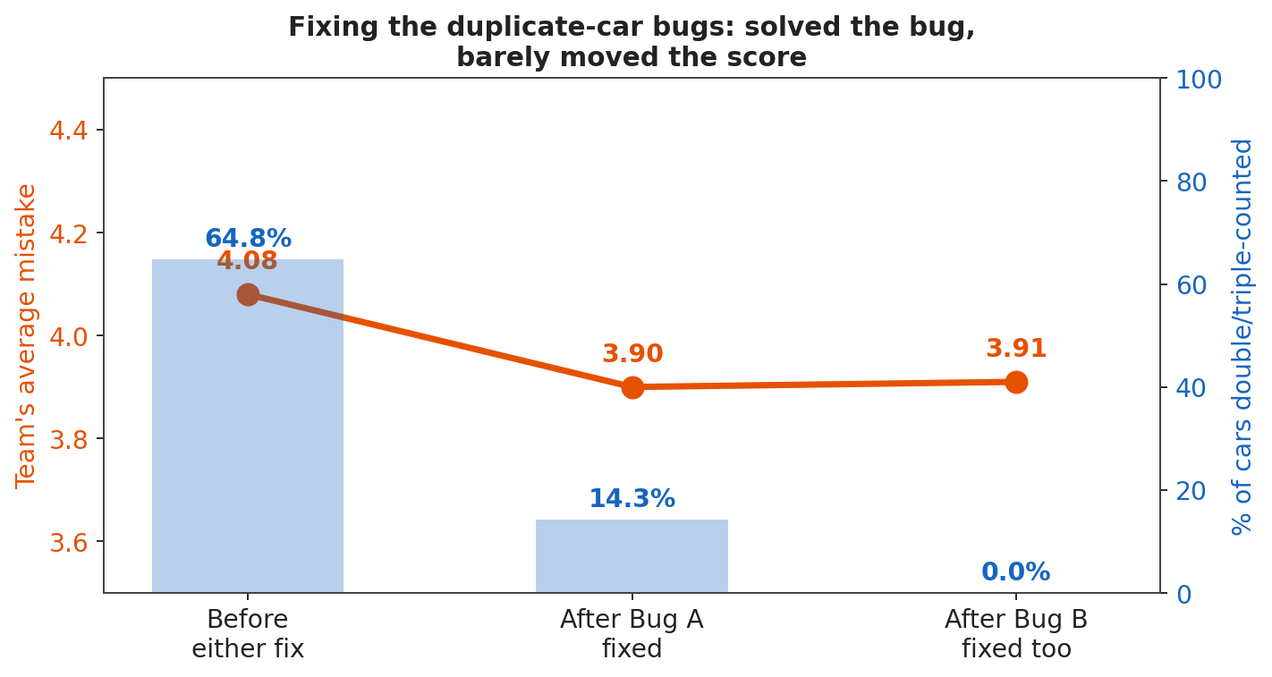
Stage | Team's average mistake | Cars double/triple-counted
Before either fix | 4.08 | 64.8%
After Bug A fixed | 3.90 | 14.3%
After Bug B fixed too | 3.91 | 0.0% — fully fixed

The duplicate-counting problem was completely solved — but the score barely moved (about 4% better). This told us duplicate-counting was never the MAIN reason the team was losing.
Source: CLAUDE.md, “Fix: FusedTracker identity inheritance” and “Further tuning and analysis” sections. v1 pipeline, mini dataset.

Evidence 6 — Even bug-free, “lone car” sightings are naturally harder
Once the duplicate-counting bugs were fully fixed, we checked again: are “only one friend saw it” cars still worse? Yes — but now for a real, not-a-bug reason.
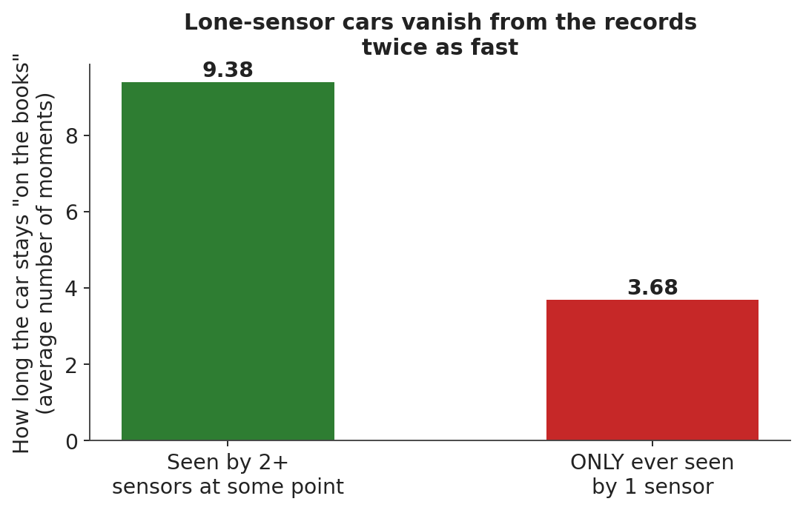
Cars that nobody else ever corroborates tend to be the fleeting, hard-to-pin-down ones to begin with — a parked car in a weird spot, a pedestrian half-hidden behind a pole, a car at the very edge of what a sensor can see. The team's score has to include them; a single sensor's own report card doesn't.
Source: CLAUDE.md, “Further tuning and analysis” section. v1 pipeline, mini dataset.

Evidence 7 — The newer system has its own problem: a “jittery” Radar
Specific to the brand-new rebuild of the system. Imagine asking Radar every second “is the car dangerously close RIGHT NOW?” If Radar's attention keeps jumping between different nearby cars instead of steadily watching ONE car, its answer can flicker — “danger!...no wait, fine...danger!” — even when nothing is actually changing.
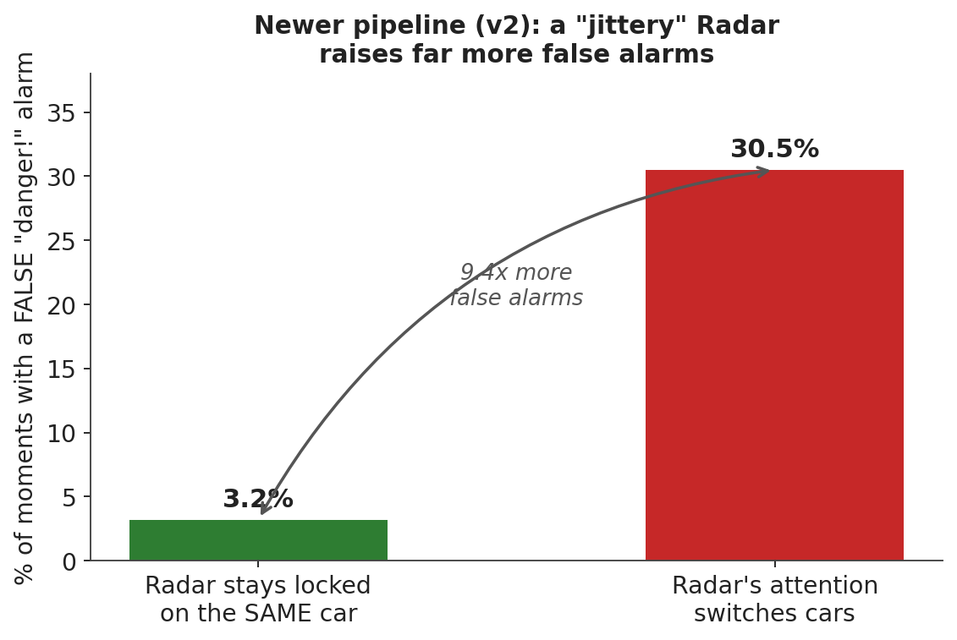
Situation | False “danger” alarm rate
Radar stays locked on the SAME car | 3.2%
Radar's attention switches cars | 30.5% (9.4x more)

Tested across 41,186 real moments, not just one example — the chance this is a coincidence is essentially zero.
Source: docs/hypotheses-2026-10-10.md, “H9 findings” and the 2026-10-19 confirmation. Script: verify_q1_track_churn_vs_ttc.py (scratchpad). v2 pipeline, trainval dataset.

Evidence 8 — With real, big data, the answer is confirmed where it matters most
This whole investigation started on a small practice dataset (404 car-moments, “mini”). The most important check — “does the team beat the best single friend in a TRUE EMERGENCY (car about to hit you in under 5 seconds)?” — had too few examples to trust (as few as 12-45 cases). So the dataset was switched to one 8x bigger (3,376 moments) and every check was re-run.
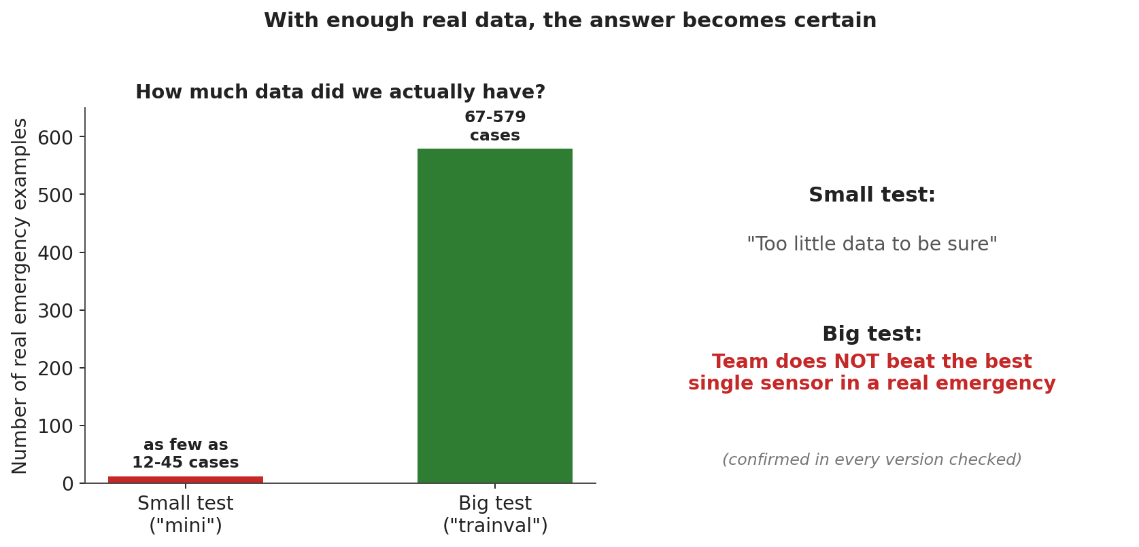
Question | Small dataset | Big dataset
Does the team beat a single friend in general? | Too little data to be sure | YES — confirmed, 2,000+ examples
Does the team beat the BEST friend in a true emergency? | Too little data to be sure (12-45 examples) | NO — confirmed REFUTED, 67-579 examples, every version checked

This is the single most trustworthy finding in this whole document: with enough real data to be confident, teamwork does NOT beat the single best sensor specifically in the moment that matters most — right before a collision.
Source: output/eval_l3/h1_refined_verdict.md and h6_verdict.md. Both v1 and v2 pipelines, trainval dataset.

What did NOT turn out to be the reason
Just as important as what we found: what we checked and found NOT guilty. These were tested directly, not guessed.
Suspected reason | What we found
The “time to collision” math formula is wrong | Ruled out — two different code paths gave byte-for-byte identical answers
Friends report slightly different spots for the same car | Ruled out — usually within ~1 meter when it's confirmed the same real car
The team is too strict about “same car” (needs a looser rule) | Tested — made things WORSE. Reverted.
(v2 only) Radar-invisible cars are always the hard ones | Does NOT hold for the newer pipeline (see Evidence 4)

What we do NOT have solid proof for yet
- Evidence 7's exact cause: a very strong statistical LINK (9.4x) was shown, but not yet a full fix-and-remeasure proof.
- “Phantom” false alarms (no real car anywhere nearby at all) have not been measured — only alarms tied to a real-but-not-dangerous car.
- The “maybe it grabbed the wrong nearby car” check (92.5% contamination) was only verified for Lidar, not yet for Radar, Camera, or the full team.
- Why the newer pipeline flips the Evidence-4 pattern compared to the older one is not yet understood.

The honest final answer
1. Real teamwork almost never happens — only ~1 in 4 “team answers” are genuinely 2+ sensors agreeing.
2. Most real cars can only ever be seen by one sensor to begin with — a hard physical limit, not a fixable bug.
3. The lone-sensor cars tend to be the harder cases — the team's average has to include them; a single sensor's own score never did.
4. Checked on enough real data to be sure: the team specifically loses in the moment that matters most — right before a possible collision.

When teamwork DOES happen, it's genuinely the best performer of all. The problem was never that combining sensors is a bad idea — it's that in this system, real combining is rare, and everything else gets dragged down by the hard, lone-sensor cases riding along with it.

